NAME of Applicant : _________________________

Yogis in Service CHIDLREN’S Teacher Training Application
YISCTT, 2020

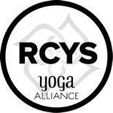

Thank you for considering the Yogis in Service 95-hour Yoga Alliance Certified Children’s Yoga Teacher Training. Following successful completion of the program, accepted students will be eligible to register at Yoga Alliance as YISCTT is a registered training program. There are a limited number of spaces and we unfortunately can’t accept all applicants. The admissions process will be closed once the class is filled. We are excited to learn more about you!

To Apply you will need to do the following:

Note, we cannot review your application until all four requirements below have been filled.

- Please fill out the YISCTT application and submit it via (a) email to yogisinservice@gmail.com, or (b) via mail addressed to Yogis in Service- Attention Catherine Cook-Cottone, Children’s Teacher Training, 153 Mount Vernon Rd. Amherst, NY 14226.

- Submit your non-refundable application fee of $50. Please write a check paid to Yogis in Service via mail addressed to Yogis in Service- Attention Catherine Cook-Cottone, Teacher Training, 153 Mount Vernon Rd. Amherst, NY 14226.

- We also require a picture of you (for our personal records) and a letter of recommendation from your yoga instructor or school/work administrator/supervisor. Submit this along with your emailed or mailed application.

- Letter of recommendation form your yoga teacher or school/work administrator.

Tuition and Cost:
Upon acceptance into the program, we will require a $300.00 deposit within 30-days. This deposit will be applied to tuition. The remaining balance of $1,200, for a total of $1,5000.00, will be required for payment of tuition. When considering if the program is right for you, it is important to note that you will also be required to purchase a set of textbooks. Our program is research-based and we will be using the latest yoga resources to guide your learning.

Note, if you pay in full by the early bird deadline, total tuition will be reduced 5% and if you are currently employed by a school or mental health facility you are eligible for another 5% off (for a max total discount of 10%). Cost of Program. This YISTT Program cost is $1,500 for the 95-hour certification. There are two payment options. We request that if you can, please make payments using cash or check.
- Pay in total by using cash or check by June = $1,500
- Pay in 2 installments = $750 ($750 due June 1 and July 7)
There will be no refunds. Please note, we are a not-for-profit (your tuition dollars pay for the training and support the mission of YIS) and this training may be considered as career development for taxes (check with your tax preparation advisor).

As you complete the application, please take as much space as you need to answer each question.

Name:
Email address:
Date of Birth:

Yoga Experience

How long have you been practicing yoga? Where do you practice? ____________________________________________________________________________________________________________________________________________________________________________________________________________________________________

How has your yoga practice impacted your life?
____________________________________________________________________________________________________________________________________________________________________________________________________________________________________

Do you currently teach yoga? Please list any previous trainings you’ve completed.
____________________________________________________________________________________________________________________________________________________________________________________________________________________________________

Yoga Teaching

Why are you, or do you want to be, a children’s yoga teacher?
____________________________________________________________________________________________________________________________________________________________________________________________________________________________________

What are your goals (professional or other) for the YISCTT training specifically?
____________________________________________________________________________________________________________________________________________________________________________________________________________________________________

Community Service with Children

Besides practicing yoga, what other community events or organizations do you take part in? Please talk about your professional work here if it is a helping profession.
____________________________________________________________________________________________________________________________________________________________________________________________________________________________________

In what ways do you feel you could most effectively serve children in your local community? Please address the match between the community needs and what you would like to contribute?
____________________________________________________________________________________________________________________________________________________________________________________________________________________________________

Program Commitment, Support, and Sustainability

The program is a 7-day intensive, formal program with various home-based projects and papers that must also be completed. We are looking for students who will be positive, ready to learn, and eager to contribute positively to the group. If you are not sure you can do this at this point in your life, please wait and apply for a different session of the program (2019, 2020, etc.)

Please write about your commitment to the program (if you are selected), the support you will have that will make your commitment possible, and your self-care practices that will help you sustain positive engagement over the week long training period.
____________________________________________________________________________________________________________________________________________________________________________________________________________________________________
____________________________________________________________________________________________________________________________________________________________________________________________________________________________________

Healthy Processing of Trauma-informed Content

The YISCTT is a trauma-informed yoga teacher training. Although we cover anatomy, instruction of poses, sequences, and philosophy (and more), there is substantial part of the program that addresses trauma and emotions. Please explain your support systems (people who support you), coping skills, and/or self-care practices. Please note, experience with trauma of helping others with trauma is NOT required. Here, we are looking for an assurance that you will be able to effectively engage in, and fully experience the trauma-informed sections of the coursework.
____________________________________________________________________________________________________________________________________________________________________________________________________________________________________
____________________________________________________________________________________________________________________________________________________________________________________________________________________________________

Medical and Physical Status
The YISCTT 20-hour week long can be rigorous. You will need to be sure you have the support of your primary care physician (and if appropriate- medical specialist) to engage in active yoga practice and assisting.

I have support of my primary care (and if appropriate- medical specialist) to complete the week long training.

Yes or No (circle one), If no, explain:

____________________________________________________________________________________________________________________________________________________________________________________________________________________________________

Attendance commitment to week long program
This program has been registered with Yoga Alliance as a 95-hour children’s teacher certification program. We have made a commitment to training teachers to the 95-hour level. The dates have been posted at www.yogisinservice.org under teacher training. 100% attendance is required. If you miss more than 10% of the meeting hours, we cannot attest to your attendance in this program and will not provide you with a certificate given our obligations to the 95-hour training. That is, you cannot not miss days, ½ days, be consistently late, or leave early. There will be no exceptions to this requirement (illness, scheduled events, family issues, etc..). If you do miss more than 10% of sessions, you can complete the program- however you will not receive a certificate. Note, certification requirements will be further delineated in program.

I understand and accept the attendance requirement for receiving my 95-hour certificate from YISCTT program.

Yes or No (circle one)

Appropriateness for YIS Children’s Training
As a YIS Children’s Trainee, you may be working with vulnerable populations. We need to know if there is any reason we should be concerned with your ability to keep those with whom we work safe.

I have been accused of, or committed a crime involving danger to others or inappropriate activity with a minor.

Yes (please explain on the back of form) or No

More about YOU?

Tell us about anything else you’d like us to know about you.
____________________________________________________________________________________________________________________________________________________________________________________________________________________________________

____________________________________________________________________________________________________________________________________________________________________________________________________________________________________

____________________________________________________________________________________________________________________________________________________________________________________________________________________________________

Thank you- a reminder that we will need all four components of your application before it can be processed (i.e., [1] application form, [2] fee, [3] photo, and [4] letter of recommendation from your yoga teacher).
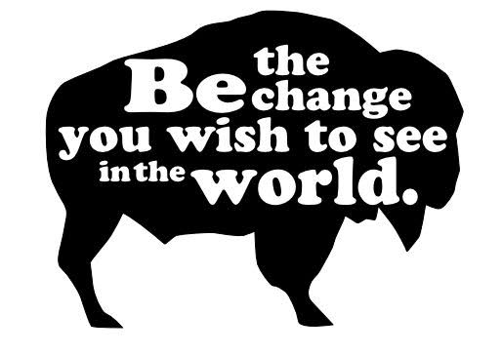
Yogis in Service, Inc.
www.yogisinservice.org

